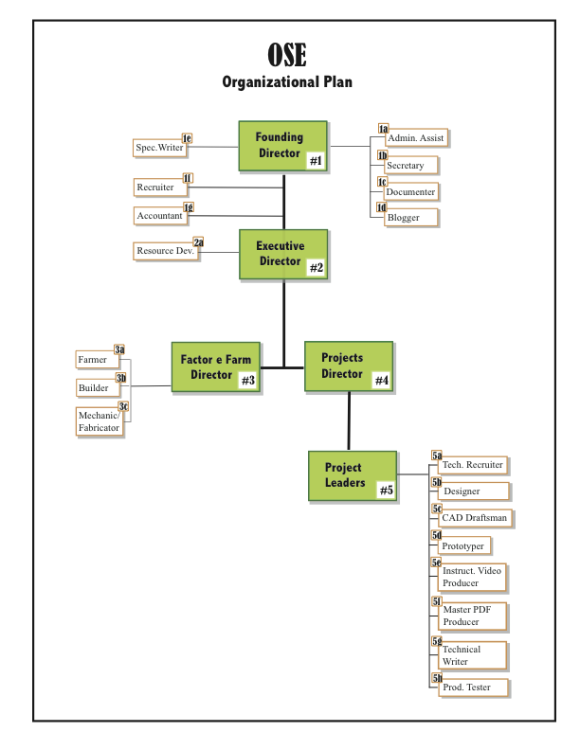

Founding Director
#1

Role in OSE:
As the founder of OSE, this person is a visionary and ethical leader modeling for his
entire staff the quality of character and competence that he desires in every person. All standards and codes must be approved by him.

As the founder of OSE, he will be the primary representative of OSE to the world. He will be the face of OSE to the media and approve all interviews or publications by any staff to the media/public.

He will assist with recruiting and approve (agree to fiduciary obligations and sign any contractual agreements) all hiring of staff or placement of all volunteers.

He will implement the “open source” philosophy in every dimension of OSE and its image to the world.

Responsibility:
Create a safe and efficient work place for multiple staff.
Assure the organization that money/space/assistance is sufficient for each person to accomplish their obligations and deliver on their promises.
Create conditions in the workplace (virtual and on campus) so that each person feels fulfilled in their lives rather than just because they meet production quotas.
Manifest a total commitment to ethical character and professional deportment toward all staff and the public.

Deliverables (Promises/Work Product)
1. Sign pay checks on time.
2. Pay materials bills on time.
3. Fulfill the requirements of the law.
3. Publish rules of safety and conduct for every area of work.
4. Maintain an archive of the history of work and report in writing regularly on both what has been done and what has been learned.
5. Meet with staff to create and maintain collaborative decision-making and to nurture feedback to sustain this learning organization.
6. Keep the trajectory of OSE before the staff and the world by all means available.

Executive Director

#2

Role in OSE
The primary role of this position is to establish best management practices for the entire OSE operations. This person will collaborate with the Founder to evolve written procedures and practices that give structure and guidance to every person and position in the organization.

This person shall ensure that all financial and fiduciary obligations and laws are clear and complied with. They will oversee the accountant position.

This person will assist the Founder in designing work roles and procedures for the campus and virtual sites so that production is efficient and on-time for the entire operation.

This person will assist the Founder in recruiting and may interview candidates in the absence of the Founder. (no hiring, however)

This person shall assist the Founder in designing and implementing line staff communication and decision making that is consistent with the OSE vision.

This person will provide assistance to line staff in establishing their internal departmental controls and communications.

This person will also act as a mentor to the Founder as this organization takes shape.

Responsibility:
Support the Founder in establishing procedures so that work is efficiently undertaken.
Provide on-site leadership when the Founder is absent the campus.
Assist with recruiting.
Oversee the daily financial transactions and prepare a monthly statement for the Founder.
Offer conflict resolution advice to the Founder or line staff with their subordinate staff.

Deliverables (Promises/Work Product)
1. Produce a clear and concise organizational plan for all OSE personnel and production.
2. Establish legal and efficient financial operations in writing that sustain work and maintain morale.
3. Provide (in writing) feedback for change to Founder from observations of OSE operations quarterly.
4. Manifest a total commitment to ethical character and professional deportment toward all staff and the public.

Factor e Farm Director

#3

Role in OSE:
This person reports directly to the Executive Director

This person may collaboarte directly (independendly of the Exec. Dir) with the Projects Director in the pursuit of improved design and performance when protoypes are being tested by Farm e staff. A brief report of outcomes of collaboration must be submitted to the Exec. Dir within 12 hours of this team-work, however.
This perso is responsible for preparing (with others) and executing a master site plan.

This person will collaborate with Exec Dir on recruiting and staffing matters.

This person shall maintain logs of work and expenditure and communicate progress/problems regularly to Exec Dir or Founder as requested.

This person will have under his authority staff that is primarily allocated to construction, to farming and agricultural enterprise, and at times be able to assist with mechanical repairs and also fabrication when campus workshops need assistance and he/she has time.

Responsibility:
Assist in the preparation and execution of a master plan for OSE campus..
Assist in recruiting and hiring support staff under this position.
Maintain logs of daily activity and expenditure so that regular reports can be submitted to Exec Director.
Manage the campus and work details so that safety is maintained.
Manifest a total commitment to ethical character and professional deportment toward all staff and the public.

Deliverables (Promises/Work Product)
1. Prepare and execute a master plan for the entire 30 acre property of OSE.
2. Prepare and execute monthly work plans for sub-staff.
3. Provide (in writing) feedback for change to Founder from observations of OSE operations quarterly.
4. Submit written financial accounting of all operations monthly.

#4

Projects Director

Role in OSE:
This person reports directly to the Executive Director

This person may collaborate directly (independendly of the Exec. Dir) with the Factor e Farm Director in the pursuit of improved design and performance when protoypes need to be tested by Farm staff. A brief report of outcomes of collaboration must be submitted to the Exec. Dir within 12 hours of this team- work, however.

This person is responsible for recruiting and supervising both on-site and virtual staff that support the production and testing of protypes.

This person directly supervises all Project Leaders for each Protoype and its completion. He must also prepare and submit regular written progress reports

This person shall maintain logs of work and expenditure and communicate progress/problems regularly to Exec Dir or Founder as requested.

This person will have under his authority staff that is primarily allocated to the completion of all 54 GVAC equipment, its design, testing and documentation.

Responsibility:
Assist in the recruiting and supervising project staff.
Report and support progress toward the efficient use of time, materials and money to complete the required prototypes on time.
Track and report on work progress and financial activity in support of it.
Manage the workshops and work details so that safety is maintained.
Manifest a total commitment to ethical character and professional deportment toward all staff and the public.

Deliverables (Promises/Work Product)
1. Prepare and build a workshop for fabrication and prototyping of all GVAC equipment..
2. Recruit and hire all production staff in collaboration with each Project Leader.
3. Provide (in writing) feedback for change to Founder from observations of OSE operations quarterly.
4. Submit written financial accounting of all operations monthly.
5. Maintain a presence on the web for production transparency to the public (as approved by the Exec. Dir.

Project Leader

#5

Role in OSE:
This person reports directly to the Projects Director. Requests for materials, labor and space are directed to th e Projects Director.

This person may collaborate directly (independendly of the projects Dir.) with the other Project Leaders in pursuit of best practices and uniformity of product and quality control. A brief report of outcomes of any collaboration must be submitted to the Proj. Dir within 12 hours of this team-work, however.

This person is responsible for recruiting and supervising both on-site and virtual staff that support the production and testing of protypes for his particular project.

This person directly supervises all Project Staff for each Protoype and its completion. He must also prepare and submit regular written progress reports suitable for webcasting.

This person shall maintain logs of work and expenditure and communicate progress/problems regularly to Project Director.

This person will have under his authority staff that is primarily allocated to the completion of one particular unit of GVAC equipment--its design, testing and documentation.

Responsibility:
Assist in the recruiting and supervising project staff.
Report and support progress toward the efficient use of time, materials and money to complete the required protoypes on time.
Track and report on work progress and financial activity in support of it.
Manage the workshops and work details so that safety is maintained.
Manifest a total commitment to ethical character and professional deportment toward all staff and the public.

Deliverables (Promises/Work Product)
1. Prepare and build a workshop for fabrication and prototyping of all GVAC equipment..
2. Recruit and hire all production staff in collaboration with each Project Leader.
3. Provide (in writing) feedback for change to Founder from observations of OSE operations quarterly.
4. Submit written financial accounting of all operations monthly.
5. Maintain a presence on the web for production transparency to the public.

Production Director

#6

[This position is for the future when all 54 GVAC modules are perfected and ready for production and marketing to support the OSE system economically]

Role in OSE:

Responsibility:

Deliverables (Promises/Work Product)

1a
Administrative Assistant

Role in OSE:
This person reports directly to the founding Director.
Keeps the Founding Director up to date and up to speed with his responsibilities.
Drafts of all documents and legal papers are readied for Foudning Dir. signature on time.
Office Manager who directs a secretary and prompts an accouintant and is the face of OSE when guests arrive.

Responsibility:
This person manages the Founding Directors office and business affairs:
1. Setting up and maintinaing his schedule.
2. Preparing and presenting him with all documents for his signature.
3. Monitor the web for data related to OSE image and public opinion.
4. Supervise the on-site secretary and organize and prioritze her work.
5. Prepare invoices and documentation for monthly financial reports to F. Dir.
from the Accountant.
6. Screen and log all official calls and web mail to OSE Founder and Campus.
7. maintainan archive of printed reports and documents in a secure locationn for
historical preservation.

Deliverables (Promises/Work Product)
1. Monthly financial reports
2. Monthly work product/production reports
3. Correspondence and e-mail generation and response.
4. Archive maintenance of critical documents.
5. Monthly calendar and advance prompts to F.Dir. in advance.

