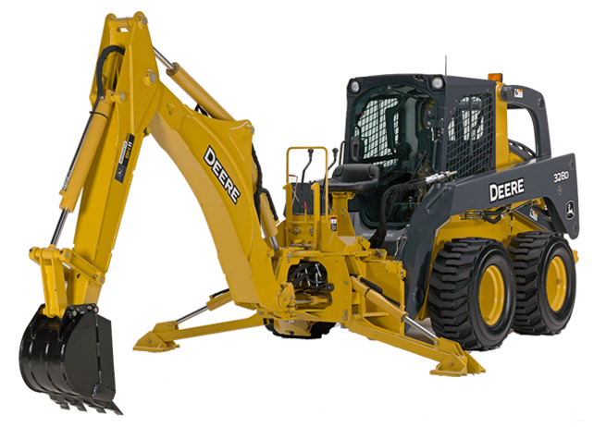
Introduction
The Global Village Construction Set is a platform of is a modular, DIY, low-cost, high-performance platform that enables fabrication of the 50 different Industrial Machines that it takes to build a small, sustainable civilization with modern comforts. It's all open source and for the good cause.
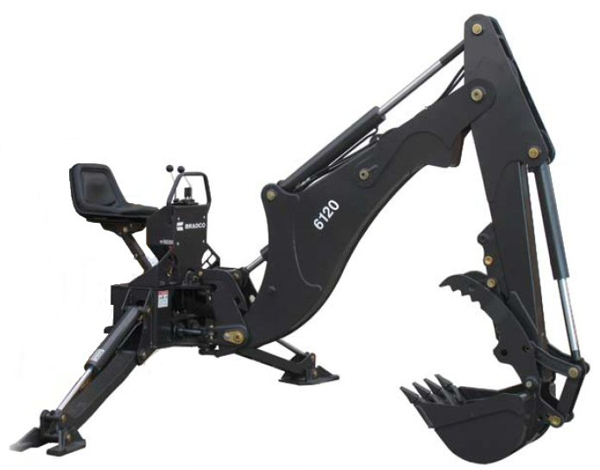
This contest is to design the entire backhoe for the GVCS. It will mount on the LifeTrac using standard bobcat interface attachment.
As with all OSE designs, the backhoe will need to follow the following principles:
- Design for fabrication- Designs should be as simple and easy as possible to build
- Lifetime design
- Intensive Scalability - Scalable in the most fundamental fashion. This specification is designed to produce a Backhoe Construction Set. All arm sections, cylinders, hoses, and the bucket should be removable so they can be replaced with parts of different sizes as necessary - like a Lego set but for real machinery. The challenge here is to design for modularity - to design the part connections such that part interchangeability is not only possible, but also practical and possibly easy.
- Extensive Scalability - additional arm sections can be added to extend the reach or increase the range of functionality to: log handling, electromagnet operation for steel works, high materials handling, jack hammering, etc)

Specifications
- See Industry Standard Backhoe for reference
- Basic operation will leave the LifeTrac plate immobile vertically but may move with the curl of the quick attach plate for extra mobility if needed, though the latter should not be the main moving mechanism of the primary boom
- Should use hydraulic cylinders, all of which will attach to Life Trac via hoses with quick couplers.
- Bucket should be quick-attach to the secondary arm, to enable easy re-tooling
  - Bucket should have removable teeth.
  - Hoses should be used only at joints, and metal tubing should be used for lifetime design whenever flexibility is not required.
- Should include stabilizer legs to prevent the machine from tipping.
  - Can mount in back of tractor and to front on the quick attach plate.
  - Takes account of Life Trac weight distribution and rated dig force.
- Operator seat and control valves are included on the attachment
  - Control valve is quick-connect with 30 gpm quick couplers
- Hydraulic valve spools:
  - 1 stabilizer leg valve (tandem motion of stabilizer legs)
  - Main boom
  - Secondary boom
  - Bucket curl
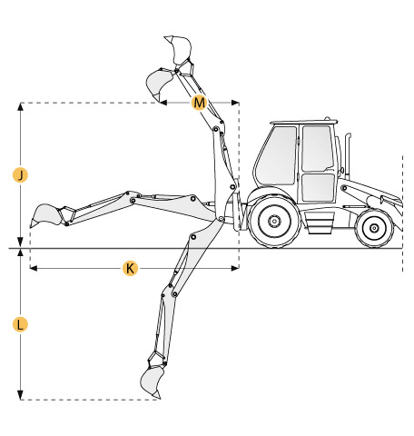
  - Allowance for bucket thumb (for grapples)

Requirements
The basic model should have one boom, one secondary boom (stick), with an optional grapple (thumb) attachment, and one bucket, all of which can pivot individually.
It must have the following specifications:
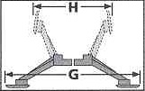
- Digging Depth Minimum (L)- 3 m (9.8 feet)
- Digging Depth Straight Wall minimum - 2.1 m (7') (Capability of bucket to travel in a straight line down vertically. This involves pivoting at all 3 joints.)
- Reach From Swing Pivot minimum (K) - 4 m
- Loading Height (J) - 2.7 m (9 feet)
- Stabilizer Spread Transport Maximum (H) - 2 m (6.6 ft)
- Stabilizer Spread Operating Minimum(G) - 2.9 m (9.5') 116 in. (2946 mm)
- Bucket Rotation 180 deg.
- Swing Arc 180 deg.
- Attachment Weight With 18-in. Bucket – Less than 2500lb (1137 kg)
- Craning Capacity Minimum - 400 kg (880 lb)
- Digging Force Using Bucket Cylinder - 2800 kg (6173 lb)
- Backhoe System Relief Setting - 16500 kPa (2400 psi)
- 457 mm (18 inch) heavy duty bucket has minimum 0.142 m3 capacity (5 cu. ft.)
- 610 mm (24") Heavy-Duty Buckets - has 0.093 m3 capacity (3.29 cu. ft.)

Rules
- Winning design will be chosen based on the design and functionality
- The competition is open to everyone
- Team entries are welcome
- You can submit several designs
- Only models uploaded to GrabCAD library will participate in the competition
- Tag your model with “Backhoe” to make it easier to find
- Privately uploaded models will be made public after the competition deadline
- Models can be done in any CAD software, including Sketchup, as long as a STEP or IGES files are also uploaded.
- Competition winner will be announced in GrabCAD’s blog
- Only models uploaded through this challenge page will participate in the competition

Prizes
- A total reward of $1000 will be distributed to the best designs.

Start
ASAP

End
2/22/2012

