Using the OSE Live USB (for Ubuntu linux users)

I am documenting my download and use of OSE Live USB .iso image.
This document is sparse text instructions with screen shots
A screencap “video” may follow.

Conventions of this text
stuff you need to know about:

- This Ubuntu users version is for those that use an Ubuntu v16 linux desktop.
- All commands issues at command line are prefixed with # in this text, to show you that it's a prompt, and they also have the (enter) in that line, to indicate that you have to press the Enter key each time you execute a command.

- I detest the normal ubuntu prohibition on acting as root, so I'm going abandon sudo on this first pass and just su to root so that I can be at root level privileges and not sudo everything.

- IF you don't want to set a root password and su into the root account, remember that every command that requires root privileges wants you to put sudo in front of the command, then type your regular account password in for authentication.

- IF you need to take a moment and read the short course on root privileges on ubuntu linux, do it now and you'll never need to hear all that yap again:
  - http://askubuntu.com/questions/155278/how-do-i-set-the-root-password-so-i-can-use-su-instead-of-sudo
  - the way to do it is at the end of the page, the part about setting a root passwd and su to root.

- You can shoot your foot off when you are root, by deleting the wrong things or changing system settings, but the efficiency and great feeling of being a real sysadmin are worth it. Just proceed with accuracy.

Use Your Own User Name, Not Mine
In this text below I will be using my username in some commands, and you can't use my username there, it won't work for you. Whenever you see me do something like
# mkdir /media/fred/usbstick (enter)
you have to substitute YOUR username instead, so if your username on the Ubuntu system is guillermo you have to use:
# mkdir /media/guillermo/usbstick

TODO for this document in future: go back and make commands sudo friendly.

This Ubuntu linux desktop system that I built for this HOWTO is based on an older Hewlett Packard computer.
Here's the system specs of the hardware that I'm using:
Pentium Dual E2140 @1.6Ghz 64 bit on an ASUS Leonite2 motherboard with Phoenix BIOS dated 2007
This system only has 2GB of RAM, but it boots from an SSD drive
It was then installed and configured as an Ubuntu desktop to use for this run-through of procedures and
Fresh install of Ubuntu 16.04.2 from the ubuntu-16.04.2-desktop-amd64.iso dloaded from:
https://www.ubuntu.com/download/desktop/thank-you?country=US&version=16.04.2&architecture=amd64

This hardware is the same used for the OSE Live installation procedure that follows.

Downloading the OSE Live ISO
per jai@solarcelldesigns.com - Jai Kumar
https://drive.google.com/file/d/0B3BMDf7eJE2IdGp2MjEtOVYtbjg/view
the file is ose0.3isohybrid.iso and it's 2,246,049,792 bytes in size and reports to WIN7 as 2,193,408KB in size.

I cheated and downloaded it with the Firefox browser right to the Downloads folder. IF you MUST dload it from the command line, do it like this:
(REAL FINAL URL and a cli download command here, after cd / into proper storage folder)

open a terminal – (right click desktop and click Open Terminal)
# su root (enter) (password prompt and entry)

insert the USB stick into a port and watch for the USB drive icon to appear at the bottom of the system stack on the left side of the desktop

Identify the device name for your USB stick
# df -h (enter) to see all disk devices https
OR
# lsblk (enter) to see all block storage devices

determine the device name of your USB stick (mine is /dev/sdf1 )
IN THIS TEXT BELOW, you must substitute YOUR DEVICE NAME in place of /dev/sdf1
IF you don't get that correct, none of this will work, so ID YOUR DEVICE NAME NOW, and type it in instead of mine.

NOTE: IF you have ANY doubt, let me tell you to leave the devices called /dev/sda(number) ALONE
Usually your Ubuntu desktop installation is on /dev/sda1 or /dev/sda2
You would not want to unmount, or format, or burn anything to those devices.

to continue, unmount the USB

# umount /dev/sdf1 (enter)

create a new, empty, dos/fat filesystem on the USB device (ERASING all previous contents !)

# mkfs.vfat /dev/sdf1 (enter)

You've now got an empty formatted USB memory stick ready to burn the ISO onto

make sure that the USB stick is unmounted
# umount /dev/sdf1 (enter)

write the ISO file to the USB stick

# dd bs=64k if=/home/fred/Downloads/ose0.3isohybrid.iso of=/dev/sdf1 (enter)

on my old computer, this took a couple of minutes (6 + minutes)

then dd reports back with statistics on the write process that it did, so that you know precisely how many and how fast.
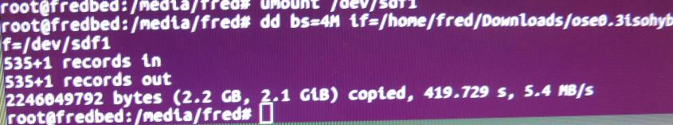

Use the sync command to synchronize the data on disk/usb with the memory.
#sync (enter)

You then remount the USB stick to confirm that the files were written to it properly

Change directory into your media directory
# cd /media/fred (enter) (YOUR media folder is NOT called fred, so put your own username in here please !)

Confirm that you are sitting in that folder currently by examining the prompt and it reports that you are indeed in
/media/fred

Make a new mount folder for the USB device, using the make dir command
#mkdir usbstick (enter)

Mount the USB stick to that folder
# mount /dev/sdf1 /media/fred/usbstick (enter)

and go to that folder
# cd /media/fred/usbstick (enter)

confirm that you are in that folder
# pwd (enter)
should return your present working directory as /media/YOURUSERNAME/usbstick

list the contents of the USB stick
# ls -l (enter)
mine looks like this:

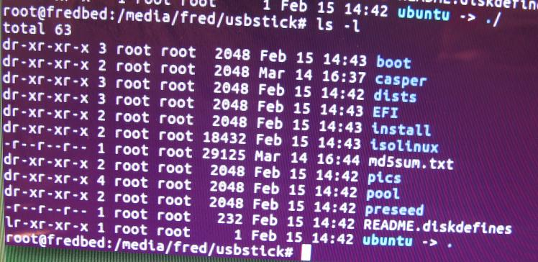
This is the directory listing of the root of the USB stick

NOW it's time to boot from the USB stick

You've got to make sure that your computer's BIOS will allow the system to boot from a USB device.
Every motherboard manufacturer / chipset manufacturer has a different BIOS look and feel, but they all have the BOOT section and they all allow USB boot. You just have to find it and enable it.
There's usually a prompt for Boot Menu at startup also, mine uses F11, yours might be different.
Make sure that you select the USB device for boot.

IF it does not boot and you get the message
“isolinux.bin missing or corrupt”
THEN go back around to the mkfs step, and use this command for the dd write to USB (slight change of device name)
# dd bs=64k if=/home/fred/Downloads/ose0.3isohybrid.iso of=/dev/sdf (enter)

When OSE Live starts up from the USB, it asks this question:

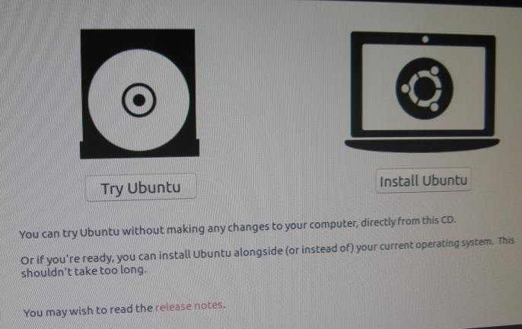
You can enjoy OSE Live using the TRY choice, but it's not fast and it won't save any of your work, it's a demo mode.
When you Install Ubuntu you'll overwrite the contents of the hard drive on the system and it will start fast and run fast.
And you'll be able to customize it and use it as a working toolset.
So click Install Ubuntu !
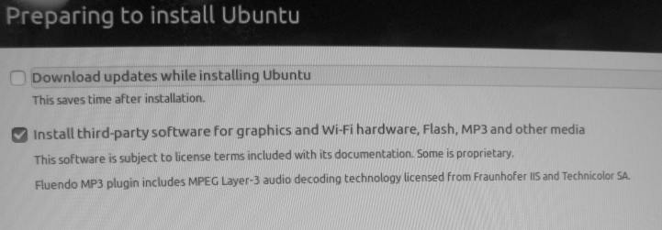

I UNCHECK this box, so that it does NOT download updates at install time.
Updates are easily done later, and they really slow down the installation, depending upon your type of internet connection.

The other choice (third party software) really doesn't make much difference.

Internet Connection: It should be an ethernet cable from a switch to the ethernet port. I didn't even try this with wireless.

At some point the partitioning software shows you any other operating system installs, so that you know that you are going to overwrite it.
You really don't want a dual boot system unless you already made those arrangements.
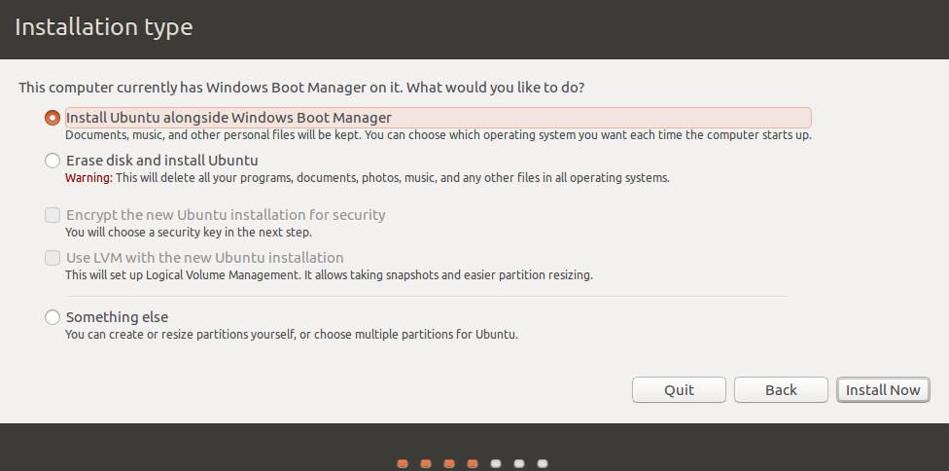
Set this choice to ERASE Disk and Install Ubuntu

And click the Install Now button.
Then it really starts transferring files. This goes pretty quickly from USB to hard drive.
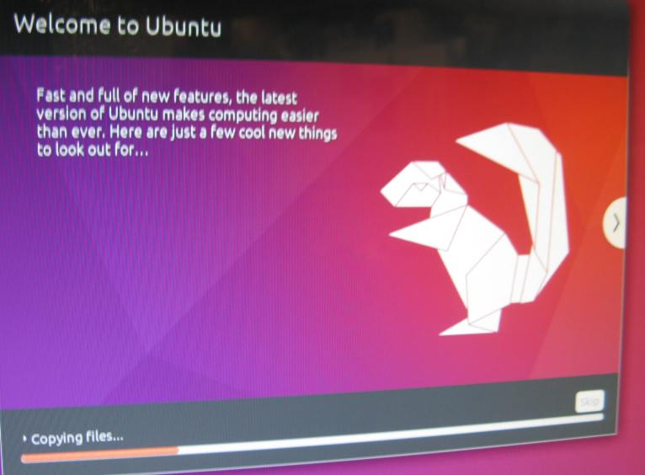
When it's done installing it will tell you to reboot the system.
Do that.
Just make sure as it turns the system off to remove the USB drive so that your computer doesn't try to boot from it again.

When OSE Live starts up, you'll get the standard Ubuntu welcome screen on the desktop:

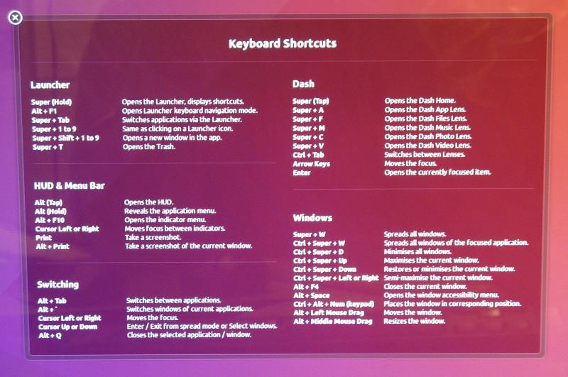

The programs pre-installed for use with the OSE Live linux desktop are:

chromium (web browser)
FreeCAD (mechanical design)
kdenlive (video editing)
vokoscreen (screencapture to video)

If you hover the mouse over the top button in the system stack at left side of desktop, you'll see that it is the Search
Click it and type free into the search field, and the system will show you the startup icon for FreeCAD.
Just click it and FreeCAD will start.
DO the same with each of the program names listed above, and you'll have all four of them open.

