Project Pitch Document – September 19, 2012

Project name – Staff for Open Source Ecology

Fellow(s) – Marcin Jakubowski

Project byline – Global Village Construction Set (GVCS) Staff 2012 (resubmission 9.18.12)

Short description – We are paying for independent contracts with the following, and their successors, if any, for 10 months: ($160k total of $228,500)

Operations Manager ($4000/month)
Master Prototyper ($4000/month)
Machine Designer ($4000/month)
Director of Development ($2500/month)
Executive Assistant ($1500/month)

Objective(s)
To transition from vision to institution, we are recruiting an Operations Manager, 3 Machine Designers (1 from this budget), Construction Director, and a Master Prototyper – in addition to continuing our Executive Assistant, Director of Development, and Video Communications Director (latter not in this budget).
The objectives are: (1), to reach a development rate of 3 prototypes per month upon success of hiring as suggested in http://opensourceecology.org/wiki/Strategic_Plan_2_Ambitious#10_Month_Development_Roadmap; and (2), to attain a $20k/month funding level from production earnings by January 1, 2013.
Our goal is to demonstrate a scalable, bootstrap funding capacity for open hardware projects by optimizing production of open source goods - and opening up associated business plans for their production.

Link to scope of fellowship(s)
The goal of this is to provide some of the key support staff as well as professional developers for the project. The world will obtain open source blueprints for critical infrastructure technologies on an ongoing basis at a rate of 3 prototypes built and tested per month.

Context
We are revamping our organization after recent learnings. While we see great potential in volunteers, they need professional guidance to be effective in delivering OSE goals. To this end, we are refocusing our strategy to acquiring the necessary management to work with a larger volunteer pool. This is intended to raise our prototyping level to 3-4 prototypes per month by the time of successful recruiting of Prototyping and Fabricator talent. Part of this involves developing a Collaborative Production earning strategy for $20k/month as well as a resource development strategy by January, 2013.

Intended beneficiaries – The ED of OSE will benefit from the support of a team. The broader open hardware community will benefit by the proof of concept of a self-funding, scalable open hardware innovation process.

Strategic partners
- Aaron Makaruk -Director of Development,
- Parker Bonnell – Executive Assistant,
- Tristan Copley Smith – Video Communications Director
- recruiting Operations Manager
- recruiting Machine Designer (MD)
- recruiting Master Prototyper (MP)

Boundary partners
- SupporTED Collaboratorium mentors - for enterprise development support
- Ewing Marion Kauffman Foundation – remaining funding of $35k is to be disbursed upon successful documentation;
- Ashoka Fellows program for potential support via Fellowship;
- Craig Campbell – OSE fund creation via conxcorp.com
- Peter Durand – strategic visualization support, Alpha Chimp

Methodology and activities
Our approach is to focus on recruiting via:
- Hand picking via personal networks and social capital, leveraging “Do you want to sell sugar water for the rest of your life or do you want to change the world?” Poach the world's best from leading centers of excellence in return for increased purpose. See http://opensourceecology.org/wiki/Recruiting_Strategy
- OSE Social Networks (about 20k audience), TED Fellows Facebook, Special Interest Groups on the internet

We will contract the people through the newly-incorporated Open Source Ecology nonprofit, and funds from Shuttleworth Foundation will go to that newly-opened bank account. We will narrow applications down to about 10-20 people to interview, and the top 3-5 will be chosen for a second interview.

The team will be structured around prototyping and support for funding the same. The direct allotment for prototyping (MP + 3 MD - $270k) : documenting (Videographer, Info. Architect - $40k) : support staff (Exec. Assist., Director of Development - $40k) budget is about 7:1:1, respectively, which is consistent with our focus on core tasks. When the 2 Machine Designers are recruited, we expect the MP alone to be able to handle building up to 4 prototypes per month by himself – assuming our Fabrication Diagram optimization process – http://opensourceecology.org/wiki/Fabrication_Diagram. The MP will also be able to access volunteer interns.

Specific activities include:
- Advisory Board Creation for recruiting
- Recruiting Infrastructure Development
- Organizational learning – tapping Recruiting strategies of advisors and collaborators
- Deploying Recruiting Automation – application form goes into a database
- Interviewing
- Onboarding
- Strategic Planning – long term prototyping and funding strategies

Outputs and deliverables
Project pitch for staff will include:
- New staff recruited, contracts signed, people on-boarded
- Executive Assistant + Director of Development + Video Communications Director – continued
- Recruiting Process Documentation – key is getting a good advisory board on recruiting – all the process needed for success in recruiting needs to be installed - http://opensourceecology.org/wiki/Advisory_Board_Strategy

Time frame
- Recruiting now
- Hire for 10 month period

Resources and budget
The $160k of the pitch includes only a part of the overall budget - http://opensourceecology.org/wiki/Define_Development_Pathway

Budget for next 10 months

EXISTING SOURCES, as of 12/8/12 | AMOUNT
Shuttleworth Project Funds | $228,500
Shuttleworth Grant Salary | $67,588
New Bank Account | $28,000
SESLOC remaining funds | $25,567
True Fans Donations | $50,000
Ewing Marion Kauffman remaining grant | $35,000
TOTAL | $434,655

Expenditures for the next 10 months (to July 1, 2012) are at http://opensourceecology.org/wiki/Strategic_Plan_2_Ambitious#10_Month_Budget

Project Implementation Needs

- Operations Manager 10 x $4000 = $40,000
- Master Prototyper 10 x $4000 = $40,000
- Machine Designer 10 x $4000 = $40,000
- Director of Development 10 x $2500 = $25,000
- Executive Assistant 10 x $1500 = $15,000
Total = $160,000

Measures of success

The following prototyping plan is proposed for the 10 month budget. Measures of success are:
- Operations Manager, Master Prototyper, Machine Designer recruited
- Operations Manager successfully contracts interim Machine Designers until full-time people are found to achieve 3 designs per month from December onwards:

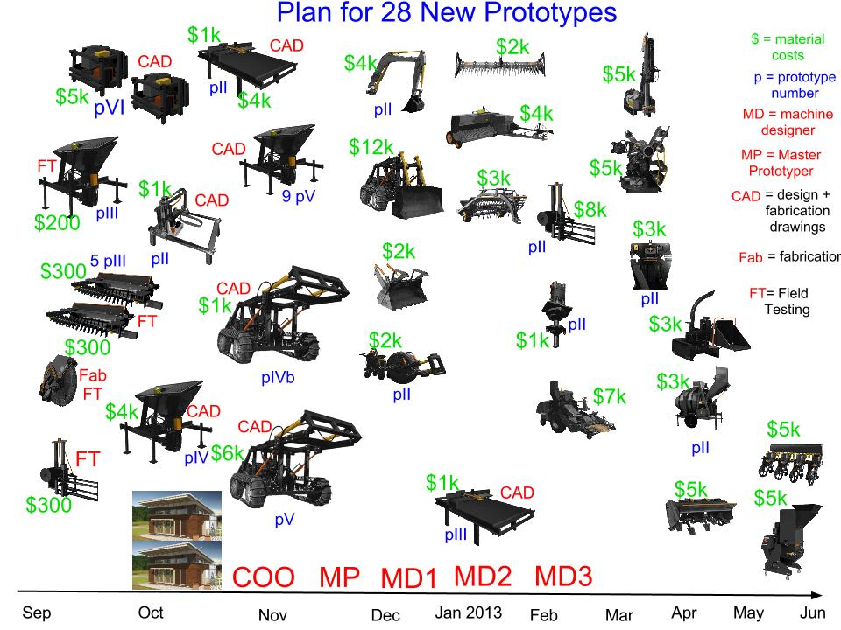
Goals are recruiting of the people by March.

- Hand picking selection process is intended to provide necessary skill by leveraging our social mission and vision.
- Once on-boarded – the evaluation is simple: machine designers are rated by how many Fabrication Diagrams they produce per month; master fabricator is rated by the number of prototypes per month
- Resource developer is rated by establishing structure for acquiring major grants by December
- Executive Assistant is rated by a weekly work plan delivery.
- Videographer is rated by producing a blog video every week, and 2 instructional videos per month.
- Review process will include 6 Month Work Plan Outline, 6 Month Work Plan Gantt, Monthly Planning and Review, Milestones Calendar that I keep for each person to track milestone delivery.
- Measurement requires institutionalization of a monthly review process.

How will you know whether the project was successful or not?
I will assess:
- if Prototypes are completed on schedule
- technical Blog Posts written on schedule
- $5k/day collaborative production enterprise model demonstrated for CEB Press machine with 8 person development teams by January 2013
- Successful resource development of $300k by first quarter fo 2013

What changes in behaviour do you expect to see?
Getting successful candidates that meet the role requirements. Nonlinear jump in prototyping rate from 1 to 4 prototypes per month.
.
What changes in behaviour would you like to see? Getting stellar candidates because of effective leveraging of advisory and social network capacity. Drastic improvement in organizational process flow. Securing $300k funding via nonprofit sector for Q1, 2013, and self-funding.

What changes in behaviour would you love to see?
Securing $50M in funding from conxcorp.com to take project to Phase III. Phase I is $2k/month budget, phase II is $20k/month budget, and Phase III is $200k/month budget.

Communication strategy
Core publicity is via personal networks and social media, and secondary, Recruiting Websites, SIGs, and VIP List.

How will you engage partners (boundary and strategic)?
I will work with Staff directly to build a background of obviousness. I will prepare strategic plans and involve the Boundary Partners, who are highly interested in the project and person.

How will you share the process of implementing the project?
We are already keeping a Control Panel for organizational development – Org. Dev. at https://docs.google.com/spreadsheet/ccc?key=0Av4ZjQn4DHJHdFZzQTFCb2RCYUhYWDlnb1NEUjBOcUE#gid=0
Started organizational development blog - http://opensourceecology.org/wiki/Marcin_Blog
Continued blogging at http://blog.opensourceecology.org

How will you share what you learn/discover/find/recommend?
We will share learnings through frequent vlogging , weekly blogging, and continuous wiki entries.

Exit/Sustainability/Viability Strategy
We would like to continue developing the size and quality of our staff. The sustainability plan is
to generate bootstrapping funding via Collaborative Production, and to engage in successful resource development. Our viability does not rely on the nonprofit funding, but production and crowd funding. We will be doing a face-lift to our True Fans campaign to double our numbers.

Risk Management

Risk in revenue generation: of the production earnings; of resource development; of upgrading our True Fans campaign. To address this, we will assure that product sales are motivated by visible effectiveness of CEB press, manifest by building a CEB Microhouse. We will further prioritize building of ancillary equipment (sawmill, backhoe, further Power Cube prototype, next iteration of LifeTrac prototype, trencher, universal auger, cement mixer, soil pulverizer, well rig, and bulldozer). All these machines will be deployed at 3 designs per month starting in December with hiring of Master Prototyper. Risk in this is contracting 3 machine designers in rapid time.
Risk: getting a sufficient number of applicants. This is mitigated by proper advisory capacity to help with the process, ad leveraging power of personal contacts and social networks.
Hiring risks: poor job performance of recruit. Quick evaluation and firing policy to be instilled; retaining a cadre of backup applicants if anyone quits/gets fired.
Evaluation risks: clear evaluation policy. Policy includes: Monthly Planning and Review; Weekly planning meeting; Calendaring of Milestones; 6 month Work Plan; monthly Gannt chart of goals.
Project Implementation Risks: stabilizing organizational processes for planning, review, evaluation. Solution: online platform begun at https://docs.google.com/spreadsheet/ccc?key=0Aj7WbjRT9mlmdFVwallOTEZHRnpkRmpjUHNKR0ZWakE#gid=0 on Flashy XM.
Acceptance of production product – solution is marketing campaign; market via social media, SIGs; publishing through Social Network.
Risk of insufficient quality control of products developed – solid technical review board to be established; addressed by extensive testing of CEB Press - pressing 10,000 bricks and stockpiling for later use;
Risks for sustainability/viability: To sustain staff, we need to make sure that we meet our Collaborative Production milestone, and that we 'get our ducks in a row' in organizational structuring.

