Power Cube
Version 4

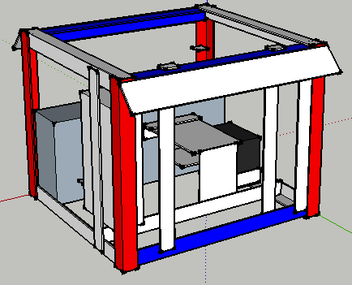

Contents
Table of Contents
Power Cube 1
Contents 2
Introduction 3
Bill Of Materials 4
Discrete parts 4
Steel 5
Subassembly Fabrication 6
Assembly 8
User Guide 15

Introduction

The Power Cube is an universal, self-contained power unit that consists of an engine coupled to a hydraulic pump for providing power in the form of hydraulic fluid at high pressure. It connects via quick couplers and quick-connect hydraulic hoses to devices such as:

- LifeTrac
  - <image>
- Microtrac
  - <image>
- Bulldozer
  - <image>
- Open Source Car (OSCar)
  - <image>

This document provides information for building and using a Power Cube as part of the Open Source Ecology (OSE) project.

Bill Of Materials

Discrete parts
Name | Qty | Dimensions | Manufacturer / Retailer | Part No.
Engine | 1 |  | Brigs & Stratton | 27 HP
Lovejoy Coupler | 1 | 2.5" x 2.25"
Hydraulic Pump | 1 | 12.11 GPM | Prince | SP20B16
Hydraulic Filter & Head | 1 | 3.5” x 5” | Zinga | AE-10
14 GPM Hydraulic Tank Strainer | 1 | 1 1/2" NPTM to 1" NPTF | SurplusCenter.com | 9-7290-100
Adapter | 1 | 1” x ¾” | SurplusCenter.com | 9-5405-12-16
90 degree elbow, male to male | 3 | ¾” | SurplusCenter.com | 9-5500-12-12
Hydraulic Quick-coupler Male | 1 | ¾” | Safeway | S71-4
Hydraulic Quick-coupler Female | 1 | ¾” | Safeway | S45-2
Hydraulic Quick-coupler Female | 1 | 3/8” | SurplusCenter.com | 9-7381
NPT Weld-In Tank Flange | 1 | 1 1/2” NTPF | SurplusCenter.com | 9-7843-24
NPT Weld-In Tank Flange | 1 | 1” | SurplusCenter.com | 9-7843-16
NPT Weld-In Tank Flange | 1 | ¾” | SurplusCenter.com | 9-7843-12
NPT Weld-In Tank Flange | 1 | ½” | SurplusCenter.com | 9-7843-8
Hose barb | 1 | ¼" NPTM x 3/8" | SurplusCenter.com | 455-BB
90 degree hose barb | 1 | 1” NPTM x 1” | SurplusCenter.com | 9-4501-16-16
Hydraulic Suction Hose | 30” | 1” | SurplusCenter.com | 9-1279
Hydraulic Oil Cooler | 1 | 14” x 14 ½” | SurplusCenter.com | 9-9232
Hydraulic Hose | 1 | 1/2” x 12” | SurplusCenter.com | 905-1212
12 Volt radiator fan | 1 | 12” - 14” | Auto Part
Rubber Fuel Line | 1 | 24” | Auto Part
Battery | 1 | 5" x 7.5" x 7.5" | Walmart | UIP-7
Hydraulic Mount | 2 | 4.75" x 3"
Galvanized Nipple | 4 | 1” | Home Depot | 64310
Galvanized Elbow | 2 | 1” | Home Depot | 510-003HN
Galvanized Washer | 4 | 2 ½” | ?? | ??
Galvanized Round | 2 | 2” | ?? | ??
Teflon Tape | 1 roll | ½” wide | Home Depot | ??
1 Gauge Wire | 30” | 1 gauge | Auto Part | ??
1 gauge ring connector  - or -  Copper tubing | 6  - or -  9” | 1 gauge  - or -  3/8” | Auto Part | ??
Ignition Switch | 1
12 V Fan Switch | 1
Bolt (Angle iron attach) | 4 | ½” x 2” x 12 TPI
Nut (Angle iron attach) | 4 | ½” x 12 TPI
Washer flat | 8 | ½”
Bolt (Engine mount) | 4 | ¼” x 2” 16 TPI
Nut (Engine mount) | 4 | ¼” x 16 TPI
Bolt (Hydraulic motor mount) | 4 | ¾” x 3.5” x 12 TPI
Nut (Hydraulic motor mount) | 8 | ¾” 12 TPI
Lock washer (Hydraulic motor mount) | 4 | ¾”
Nut (Fan mount) | 4
Bolt (Fan mount) | 4
Bolt (Solenoid mount) | 2

Steel
Type | Width | Thickness | Total Length (rounded up)
Angle | 2" | ¼" | 370" (Frame, support)
Angle | 2” | 1/8” | 6” (Key switches, choke)
Plate | 8" | ¼" | 38" (Engine mount, gas tank)
Plate | 2” | ¼” | 98” (Oil cooler mount, Battery mount)
Plate | 6" | ¼" | 24" (Hydraulic reservoir)
Plate | 4” | 3/8” | 54” (Quick attach)
Tube | 4” x 8” | ¼” | 14 ½” (gas tank)
Tube | 6” x 12” | ¼” | 27 ½” (Hydraulic reservoir)
Tube | 2.5” dia | 1/8” | 2” (section strainer extension)
Tube | 1 9/16” | 1/8” | 12” (Galvanized Muffler Pipe)
Tube | 6 cm | 1/8” | 14” (Galvanized Muffler Pipe)
Plate | 8” | 3/16” | 3” (Galvanized muffler mount)
Grill | 12” | 13 gauge | 20” (Oil cooler grill)

Subassembly Fabrication
Many of the items listed in the Bill Of Materials require preparation before use in assembly of the Power Cube. This includes drilling and cutting steel up to 3/8” in thickness. These are the parts for assembling a Power Cube.

- Engine mounts
  - ¼” x 8” x 12” Plate
  - ¼” x 8” x 9” Plate
<image>
  - ¼” x 2” x 2” x 8” Angle
  - ¼” x 2” x 2” x 29” Angle
<image>
- Hydraulic pump mount
  - ¼” x 8” x 8” Plate
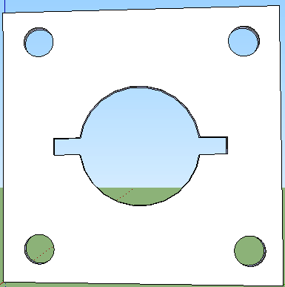
<image>
- Quick attach mounts
  - [2] 3/8” x 4” x 27” Plates
<image>
- Fuel tank
  - [2] ¼” x 4” x 8” Plates
<image>
  - ¼” x 2” x 24” Plate
<image>
  - 4” x 8” x 14 ½” Tube
<image>
- Oil Cooler Mount
  - [2] ¼” x 2” x 24” Plates
  - [2] ¼” x 2” x 22” Plates
  - [2] ¼” x 2” x 1” Plates
  - 13 gauge x 20” x 12” Expanded steel
<image>
- Key Switches and Choke
  - [3] 1/8” x 2” x 2” x 2” Angle
<image>
- Electrical cables
Note: The connectors can be purchased from an auto parts store – be aware that they usually require a crimper to attach to the cables. Alternatively, 3/8” copper tubing can be used in 1 ½” long pieces instead. Strip 1 ½” insulation from the cable, fully insert fully into 1 ½” copper tube, flatten end with a hammer and drill hole.
  - [2] 11” 1 gauge
  - 8 ½” 1 gauge
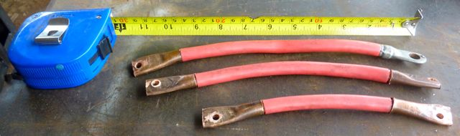
- Battery Mount
  - [2] ¼” x 2” x 2” x 4 3/4” Angle
  - [2] ¼” x 2” x 5/8” Plate
<image>
- Oil filter Assembly
  - Assemble as shown, using teflon tape on all threaded components.
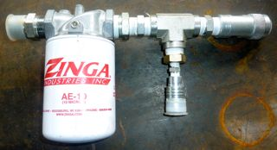
  - The parts for this are (from left to right): 1” nipple, Oil filter and header, 1” to ¾” reducer, ¾” nipple, ¾” T adapter, ¾” to 3/8” recucer, ¼” quick connect, ¾” T adapter and ¾” quick connect.
- Hydraulic reservoir
  - [2] ¼” x 6” x 12” Plates
  - ¼” x 6” x 12” x 27 ½” Tube
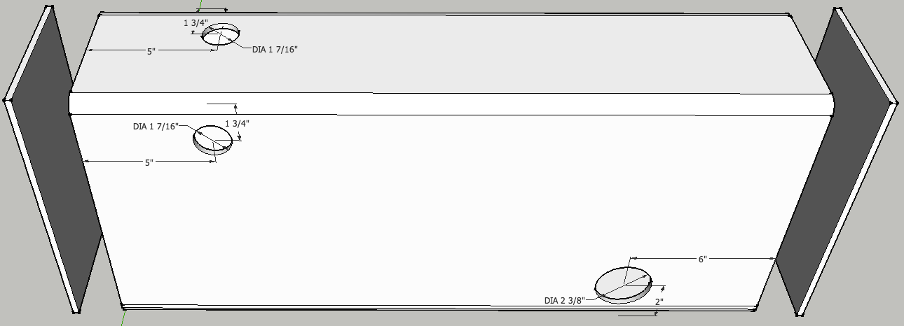

  - 2” x 2 ¼” x 1/8” Tube, flange, strainer and hose barb
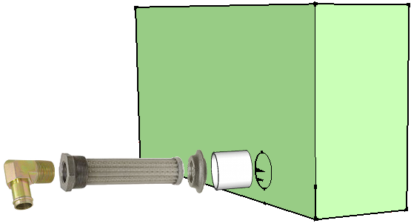

Assembly
Power Cube assembly requires all the parts listed in the Bill Of Materials to be available and prepared as detailed in the “Fabrication” section (above). Assembly requires a welder (electric or torch) capable of welding metal 3/8” thick.

- Optional: Jig for frame assembly
The welding “jig” in the image below is helpful to insure square angles while assembling the Power Cube.
Materials List
¼” x 2” x 2” Angle Iron: 14'
½" Rebar: 7' 2”
Cut List
Type | Length | Dimensions | Quantity | Color
Angle | 22" | ¼” x 2 x 2" | 2 | (red)
Angle | 26" | ¼” x 2” x 2” | 2 | (yellow)
Angle | 29" | ¼” x 2" x 2 | 2 | (green)
Rebar | 30.5" | ½" | 1
Rebar | 27" | ½" | 2

- Frame
  - Top / Bottom Rectangles
Position two ¼” x 2” x 2” x 29” pieces angle iron on top of two 27” angle pieces as shown below. Check that all joints are square, then tack and weld joints.
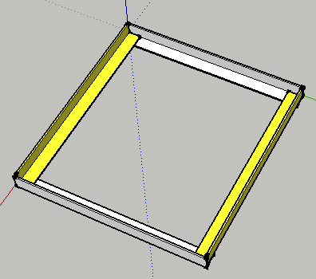

  - With one welded rectangle on the bottom, position the 24” pieces outside corner joints as shown below. Check that the angles are square, then tack and weld securely.
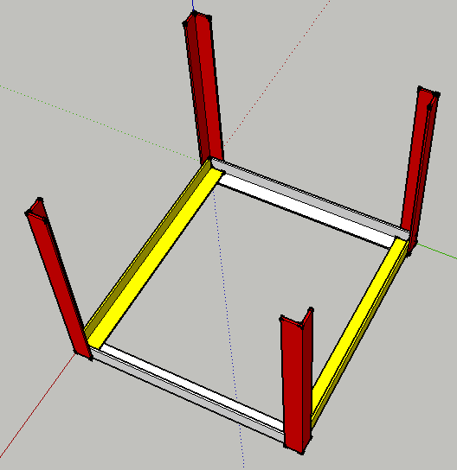
  - Position the second rectangle as shown below, then tack and weld. Inspect all corners to verify secure welds.
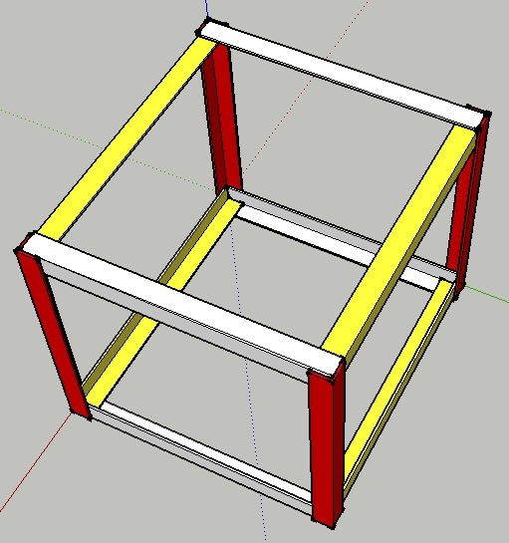

- Gas tank
All welds assembling the tank must be quality welds that do not leak. Be careful not to “over weld” the tank.
  - Clean the inside of the ¼” x 4” x 8” tube and the two ¼” x 4” x 8” plates – anything left on these surfaces will end up in the gasoline and could clog the engine when started. Tack and weld the plates on each end of the tube, taking care to orient the top plate with the filler hole as shown in the diagram below.
<image>
  - Weld the ¾” tank flange to the smaller hole.
<image>
  - Perform a “soap bubble” test on the tank. Securely cover the larger hole (use something like strong tape), pressurize the tank using the smaller hole and cover the tank surface with soapy water. Look closely for new bubbles, mark any leaks and re-weld securely. Repeat soap bubble test if re-welded.
  - Tack and weld the gas tank mount (¼” x 2” x 24” plate) to the frame.
  - Tack and weld the gas tank to the gas tank mount as shown below, leaving a 2” space as illustrated below. This space is necessary for changing the cooler, if necessary.
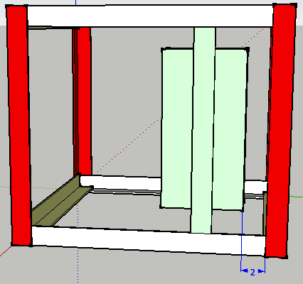

- Hydraulic tank
All welds assembling the tank must be quality welds that do not leak. Be careful not to “over weld” the tank.
  - Clean the inside of the tube and the two end plates – anything on these surfaces will end up in the hydraulic oil and could damage the pump or cylinders.
  - Tack and weld the 6” x 12” plates to both ends of the 6” x 12” tube. Pay attention to the orientation of the plate with the filler hole and the side of the tube with other holes – see the diagram below.
<image>
  - Tack and weld the strainer extension tube to the tank, centered around the strainer hole.
  - Insert the strainer into the tank flange and insert it into the strainer extension tube – verify that it slides in without binding or bottoming and that the flange is flush with the end of the tube. Remove the strainer from the flange, then tack and weld the flange to the tank.
CAUTION: Keep the strainer away from the welding, as its thin wires burn easily.
  - Perform a “soap bubble” test on the tank by securely covering the larger hole (use something like strong tape), pressurizing the tank using the smaller hole and cover the tank surface with soapy water. Mark any leaks and re-weld securely. Repeat soap bubble test if re-welded.
  - Weld it to the frame as shown with 4, 1” welds. The tank is ¼” and it can be easily damaged by over-welding. Spacers may be needed on the sides near the top to keep everything snug.
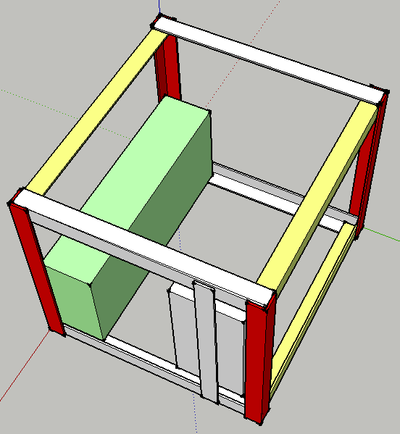
- Engine Mounts and Hydraulic Pump Mount
  - Position the ¼” x 2” x 2” x 29” angle 12 ½” from the hydraulic tank (see diagram below). Tack and weld it to the frame.
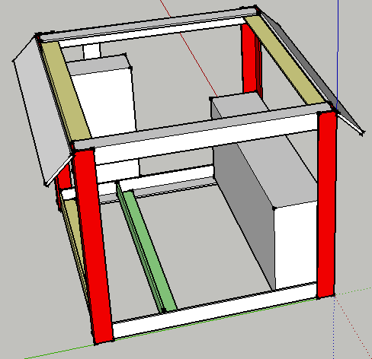
  - Place the ¼” x 8” x 8” plate on the angle iron and secure with two bolts.
  - Place the ¼” x 2” x 2” x 8” angle on top of the ¼” x 8” x 12” plate, align the bolt holes and secure with two bolts. Align this assembly with the ¼” x 8” x 8” plate in the prior step and position the angle against the hydraulic tank, 3” below the tank top as in the diagram below, then tack and weld to tank.
<image>
  - Tack and weld the corner formed by the two 8” plates.
  - Examine the engine shaft – it should be 2” long. If longer, cut the shaft to extend no more than 2” from the case. This length is necessary for the coupling.
<image>
  - Gently hoist the engine and lower it on the mounting plate, centering it on the plate. Verify the engine mounting holes are evenly spaced on each side of the plate and the shaft extends through the hole without touching.
  - Thread the ¼” x 2” engine mounting bolts each about half-way with nuts, then lift each side of the motor and insert the bolts into the engine mounting holes. Adjust the nuts so the space between the plate and the engine is ½” and the engine rests evenly on all four bolts. Lightly weld the bolts in place to the plate.
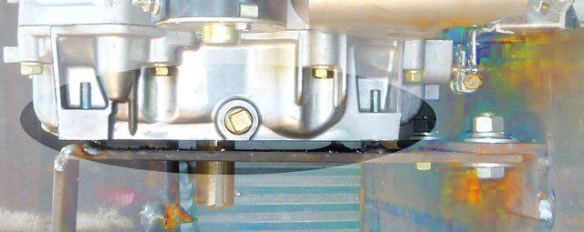

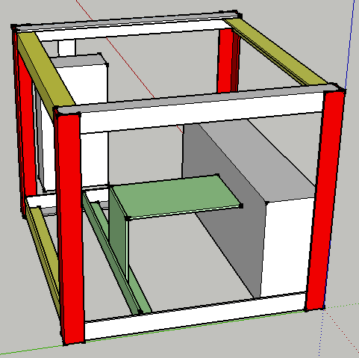

- Battery mount
  - Weld the ¼” x 2” x 5/8” plates to the ends of the ¼” x 2” x 2” x 4 3/4” plates as shown below.
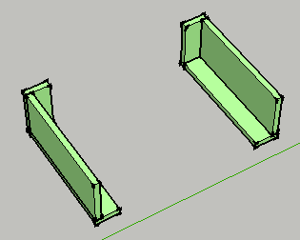

  - Weld the two mounts to the angle iron and tank to form a rectangle for the battery as shown below.
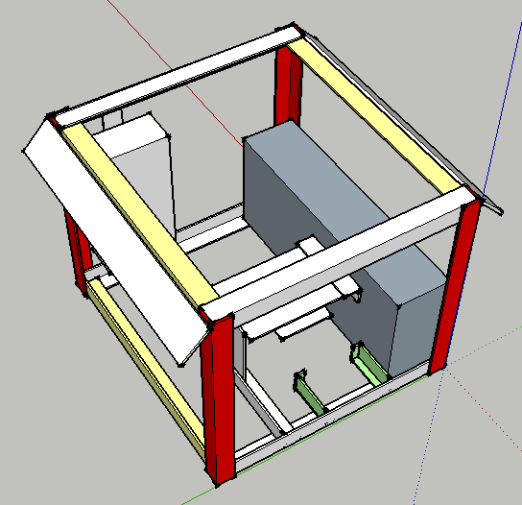
  - After the mount has cooled, lower the battery into the rectangle to verify a proper fit.
- Oil cooler and fan mounts
  - Position the two ¼” x 2” x 22” plates to the outside of the frame, adjust so the oil cooler mounting bolts match the holes in the plates and is positioned as in the diagram below. Tack and weld the mounts in to the frame. Verify that the oil cooler bolts match the holes in the mounts.
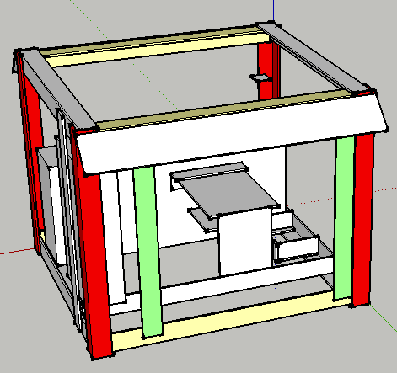
  - Use the mounting holes in the fan shroud and the oil cooler width for positioning the mounting plates as shown in the diagram below. Position the four ¼” x 2” x 1” plates, then tack and weld. Position the two ¼” x 2” x 24” plates against the 1” plates, then tack and weld. Place the fan on the supports and mark the mounts with bolt hole positions. Place the bolt heads against the fan mounting plate and weld in place. Verify that the bolts match the holes in the fan. Inside the frame, adjust the fan position to to position fan shroud ¼” from oil cooler fins. Be careful with radiator as the delicate fins are easily bent and damaged.
  - Place the 9 gauge x 12” x 20” oil cooler grill in front of the oil cooler mounting plates, positioned to cover the entire oil cooler, then weld in place.
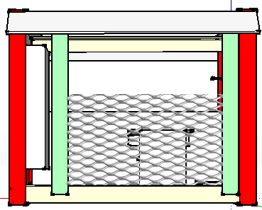
- Screw the filter assembly into the flange on the side of the hydraulic reservoir.
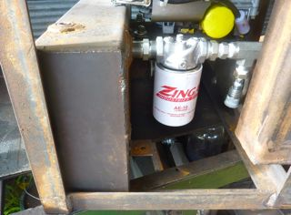
- Connect the 1” suction hose between the strainer and the pump intake.
- Connect a male ¾” quick connect hydraulic coupler to the pump output. An adapter is necessary.
- Connect a female ¾” to ¾” elbow to the cooler port nearest the battery cage. An adapter is necessary.
<image>
- Connect one end of the ¾” x 1' hydraulic hose to the second cooler port, then connect the other end of the ¾” x 1' hydraulic hose to filter assembly.
<image>

Mount the hydraulic fittings, hydraulic motor, gas tank, battery and wires. Finish it up to complete your very own OSE PowerCube 4.0!

User Guide
This section is intended for the end user of the Power Cube.

- Caution
  - Weight
  - Hydraulic hazards
  - Ventilation
- Mounting
  - Quick attach connector
- Initial startup and testing
  - Initial Setup
    - Gasoline
    - Hydraulic Fluid
    - Battery Connection
  - Startup
  - Hydraulic Test
- Routine use
- Maintenance
  - Check fluids
  - ? ? ?
- Troubleshooting
  - Engine won't start
  - Loud noise
  - No hydraulic power

