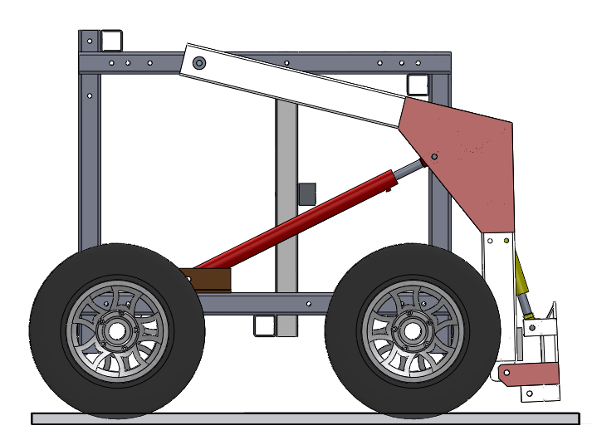
Vehicle CofG
Load CofG

